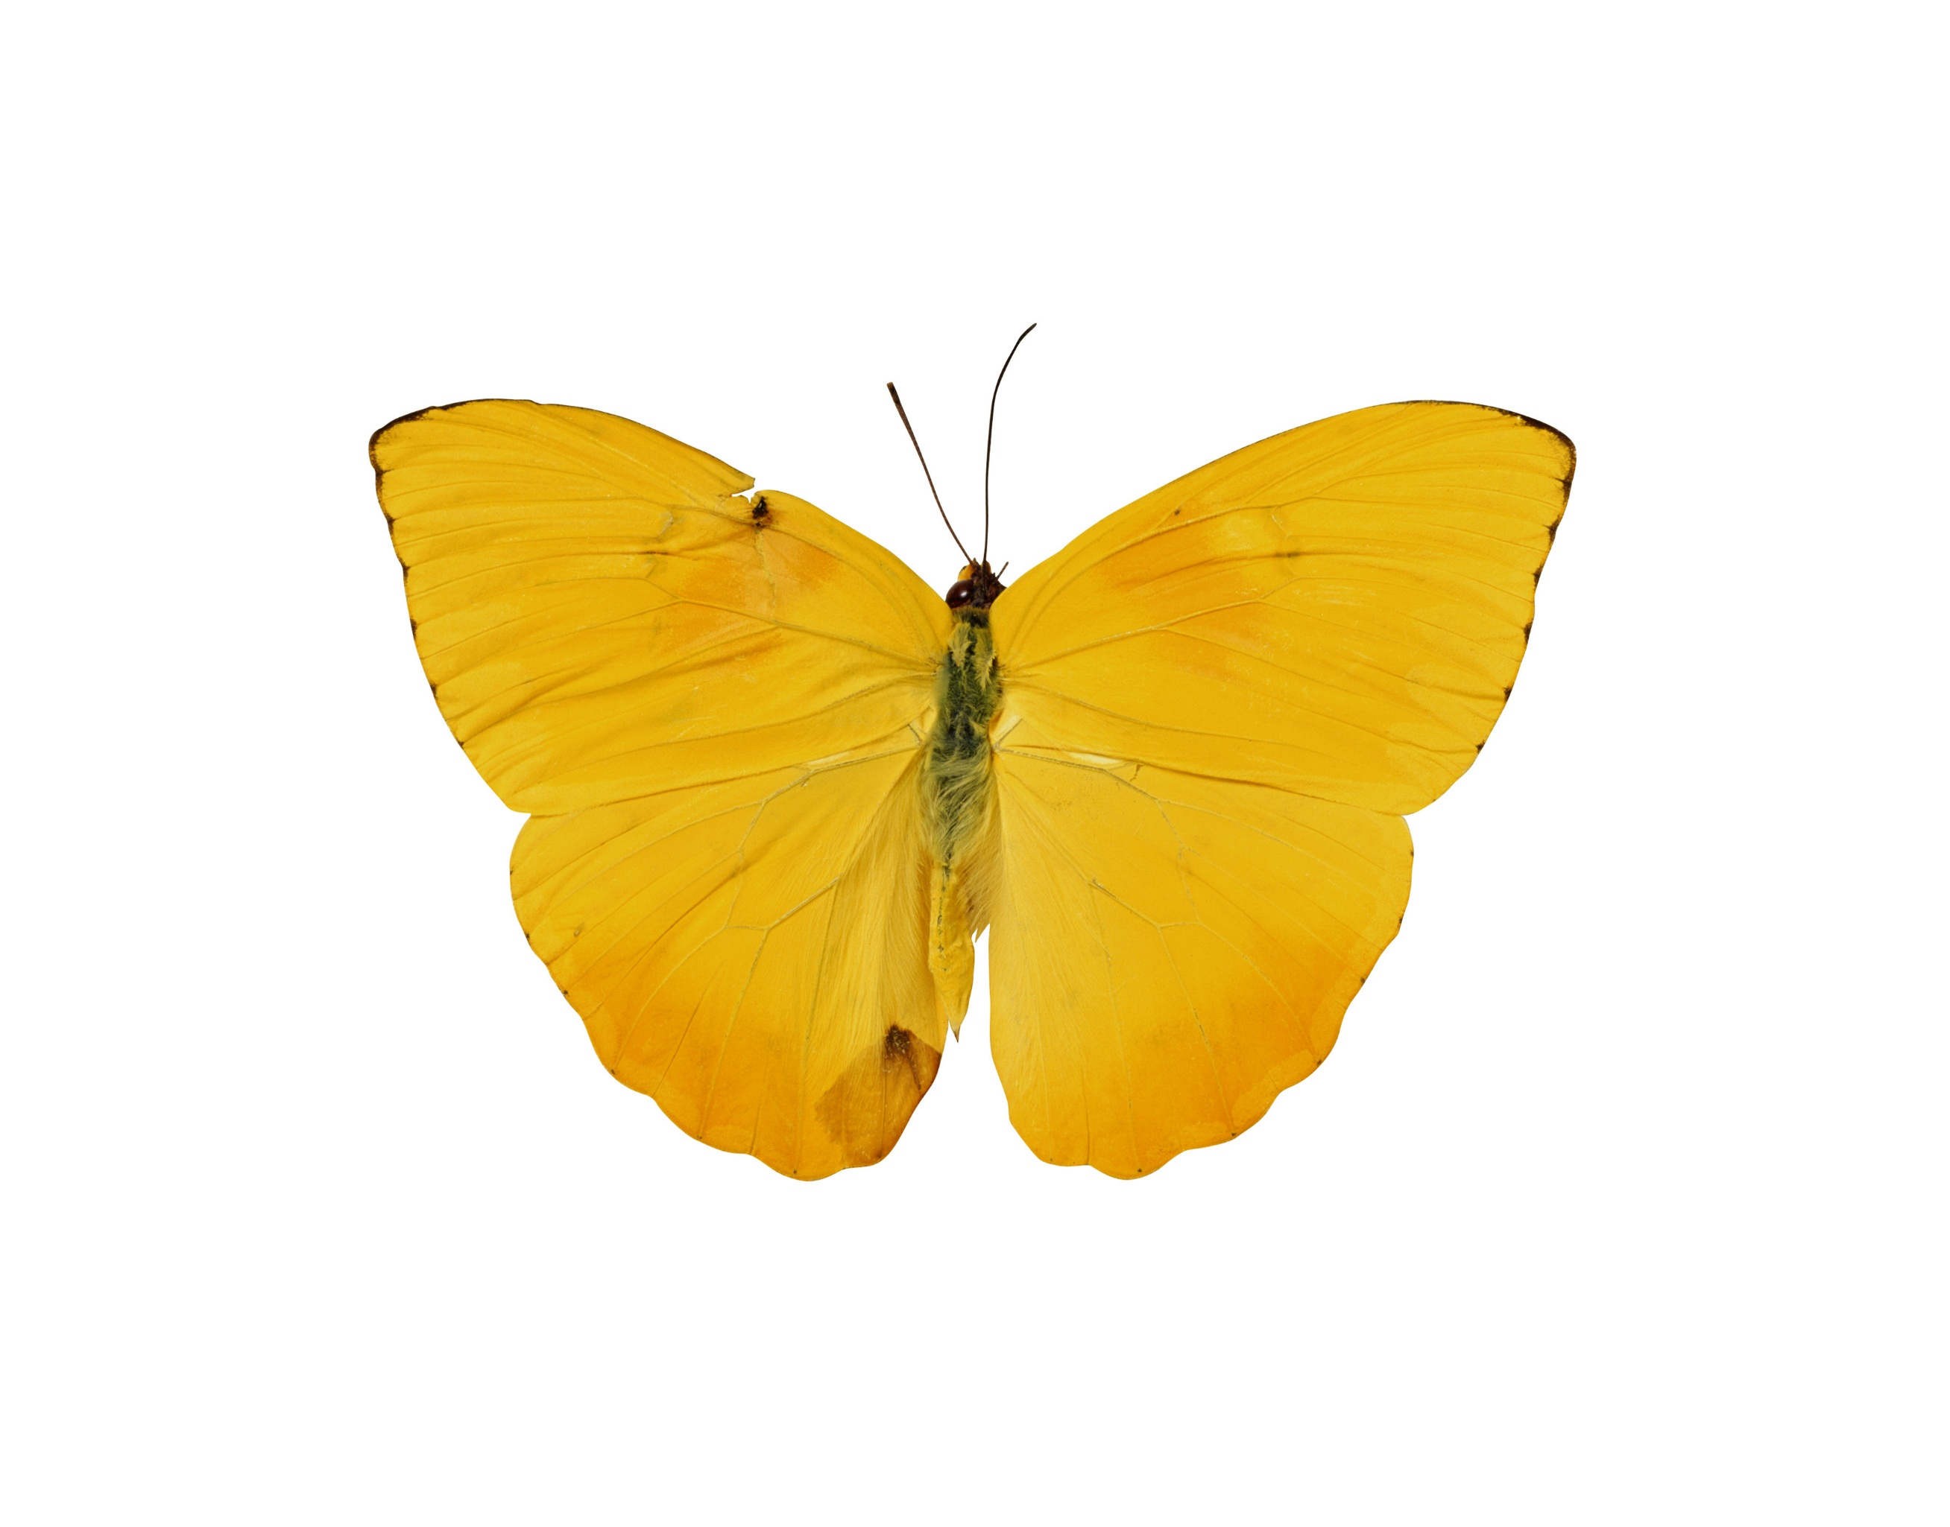

Dongyu Li  
CPS580  
JU SHEN

AStarSearch

**fINAL REPORT**

**1. Heuristic function:**

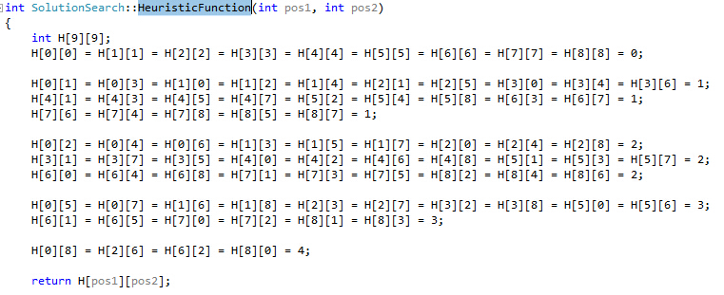

I compute each of the step in the Manhattan distance and initialize them. This is based on a matrix of how the value should be in the right position.

This is the matrix:

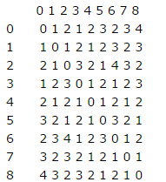

For each g() value of the node, it increases by “1” from the node parent.

**2. FINAL RESULT IMAGE:**

